📄 QUALITY ASSURANCE (QA) PLAN
Dizi Kutusu

Table of Contents
- Contributors
- Quality Assurance Strategy
- Quality Factors & Metrics
- Test Plan
- Bug Tracking
- Task Matrix

1. Contributors
- Şevda Yağmur Asal
- Oğuz Giray Bori
- Deren Berk
- Mert Dönmez

2. Quality Assurance Strategy
Overview
The Quality Assurance strategy of Dizi Kutusu aims to ensure that the system is reliable, secure, maintainable, and user-friendly. The QA process includes structured testing throughout the development lifecycle. Testing will be conducted incrementally after each module implementation to detect defects early.
The project follows a test-oriented modular development approach, where backend logic is tested independently before integration with the user interface.

Testing Methodologies
The following testing techniques will be applied:
1. Unit Testing
- Used for testing individual service functions
- Example: Testing register_user() function
- Tool: pytest
2. Integration Testing
- Testing interaction between routes, services, and database
- Example: Testing full user registration flow
3. System Testing
- Testing the full workflow of selected use cases
- Example: Login → Add Series → Rate Series
4. Usability Testing
- Manual testing of UI clarity and navigation
- Small user feedback collection

Automated vs Manual Testing
System Component | Testing Type
Authentication logic | Automated
Service layer logic | Automated
Database operations | Automated
API endpoints | Automated
UI layout and design | Manual
Usability evaluation | Manual
Automated tests will be executed before each major commit to ensure regression prevention.

3. Quality Factors & Metrics
The project defines four primary quality factors:
Quality Factor | Description | Measurement Metric
Performance | System responds quickly under normal usage conditions | Average response time below 2 seconds during testing
Security | Protection of user data and secure authentication | All passwords encrypted; no unauthorized access during testing
Maintainability | Code is easy to understand and modify | Clear modular structure and proper documentation provided
Scalability | System can handle increased number of users | System functions properly with at least 50 simultaneous test users
Compatibility | System works across different browsers | Successfully tested on Chrome and Firefox

Measurement Approach
- Performance measured using response time logs.
- Security validated by verifying password hashing and input validation.
- Usability measured via short survey among at least 5 users.
- Maintainability evaluated by code structure and static analysis tools.

4. Test Plan

Test case 1 User-Registration
Test ID: TC-01
Test Type: Integration Test

Precondition:
User is not registered in the system.

Input:
Valid email and password
Steps:
1. Send POST request to /register endpoint
2. Backend validates input data
3. Password is hashed
4. User is stored in the database

Expected Result:
• User account is successfully created
• Password is stored as hashed
• HTTP 200 response returned

Actual Result:
• HTTP 200 response received
• User saved to database: True
• Password hash verified: True

Status:
PASS
-------------------------------------------------------------------------------------------------------------------------
Test Case 2 – Duplicate Email Registration
Test ID: TC-02
Test Type: Validation / Integration Test

Precondition:
A user with the given email already exists.

Input:
Existing email and new password

Steps:
1. Send POST request to /register with an existing email
2. Backend checks database for duplicates
3. System prevents duplicate user creation

Expected Result:
• Registration rejected
• No duplicate user created
• Existing user data remains unchanged

Actual Result:
• Duplicate prevented: True
• Original password preserved: True

Status:
PASS

Test Case 3 – Successful Login
Test ID: TC-03
Test Type: Integration / Authentication Test

Precondition:
User is already registered in the database.

Input:
Valid email and password

Steps:
1. Send POST request to /login endpoint
2. Backend retrieves user from database
3. Password hash is verified
4. Session is created

Expected Result:
• HTTP 200 response returned
• User successfully authenticated
• Session contains user email

Actual Result:
• HTTP 200 response received
• Session user active: login@example.com

Status:
PASS

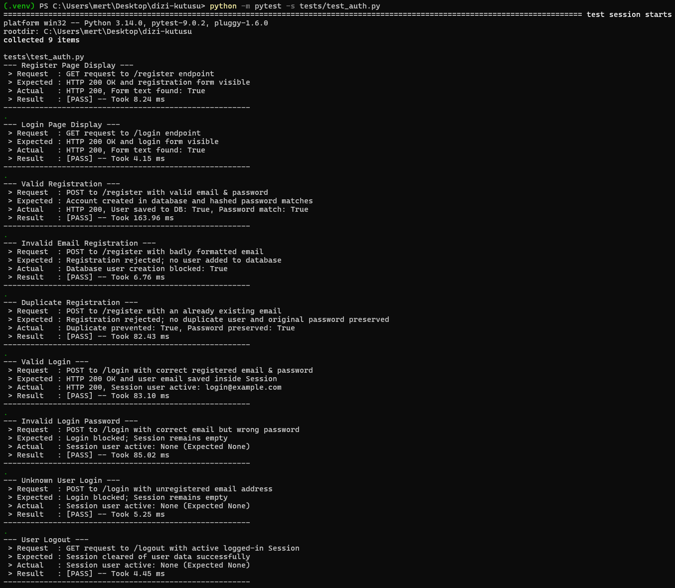
Test Case 4 – Add Series
Test ID: TC-04
Precondition: Logged in user
Input: Valid series data
Expected Result:
- Series stored in DB
- Confirmation message shown

Test Case 5 – Rate & Review Series
Test ID: TC-05
Precondition: Series exists
Input: Rating between 1–5 and review text
Expected Result:
- Rating saved
- Review saved
- Average rating updated

5. Bug Tracking
All detected bugs will be tracked using GitHub Issues.
Each bug report will include:
- Bug ID
- Description
- Steps to reproduce
- Expected result
- Actual result
- Severity level (Low / Medium / High)
- Assigned team member
Bug lifecycle:
Open → Assigned → In Progress → Resolved → Closed
Critical bugs must be resolved before demo presentation.

6. Task Matrix (QA Plan Document)
Task | Responsible
QA Strategy Writing | Şevda
Test Case Design | Oğuz
Metrics Definition | Deren
Documentation & Formatting | Mert
Final Review | All Team

